PREPAID ENERGY METER
IoT-Based Smart Prepaid Energy Meter using ESP32 and PZEM-004T
A Major Project Report
Ganesh Narayan – 234120045
Aditya Sahu – 234120047
Pranay Vichave – 234120065
Ayush Walanj – 234120067
Aryan Yadav – 234120068
Riya Singh – 234120054



VEERMATA JIJABAI TECHNOLOGICAL INSTITUTE
DIPLOMA IN ELECTRICAL ENGINEERING
2025 – 2026
Under the Guidance of
Prof. Sarika Dongre

ACKNOWLEDGEMENT
I would like to express my profound gratitude to my project guide, Prof. Sarika Dongre Ma'am, for her continuous support, expert guidance, and motivation throughout the development of this IoT-Based Smart Prepaid Energy Meter project. Her consistent feedback and valuable suggestions played a crucial role in shaping the technical foundation and successful completion of this work.
I am sincerely thankful to the Electrical Department of Diploma, Veermata Jijabai Technological Institute, for providing all necessary facilities, laboratory equipment, and a cooperative learning environment. I would also like to acknowledge Sudhir Bhil Sir for giving me the opportunity to undertake this project and for extending institutional support whenever required.
I am also grateful to our friends and classmates who encouraged us and provided helpful inputs, especially during troubleshooting and evaluation stages. Lastly, I extend special thanks to our families for their constant encouragement, patience, and moral support, which kept us motivated throughout the project journey.
This project has not only enhanced our technical understanding of IoT systems, embedded programming, energy metering, and relay control, but also strengthened our ability to work systematically, manage deadlines, and apply theoretical knowledge to practical implementation.

ABSTRACT
The rapid increase in electricity consumption and the limitations of conventional postpaid billing systems have highlighted the need for more efficient and transparent energy management solutions. This project presents the design and implementation of an IoT-Based Smart Prepaid Energy Meter using the ESP32 microcontroller and PZEM-004T sensor module, developed as an academic demonstration prototype.
The system integrates real-time energy measurement, prepaid billing logic, dynamic tariff management, IoT-based remote monitoring, intelligent load management, and simulated theft detection into a single embedded platform. The PZEM-004T module continuously measures voltage, current, power, and energy consumption, while the ESP32 processes this data and deducts the cost from the prepaid balance using power-time integration.
A unique virtual time concept is implemented for demonstration purposes, where 1 real minute equals 4 virtual hours, enabling rapid observation of dynamic tariff changes. The tariff cycles through four values – Rs.4.00, Rs.6.50, Rs.8.00, and Rs.5.50 per kWh – within a short demonstration window. The system simultaneously calculates the equivalent cost at a constant tariff for comparative analysis.
A 4-channel relay module controls the main supply (GPIO4), theft simulation relay (GPIO25), essential load (GPIO26), and non-essential load (GPIO27). When the user-defined minimum balance is reached, non-essential loads are automatically disconnected while essential loads remain active. An ILI9341 TFT display provides local real-time visualization, while an IoT web dashboard accessible over Wi-Fi allows remote monitoring and control.
Overall, this project demonstrates the effective integration of smart metering, prepaid billing, dynamic pricing, IoT connectivity, and load prioritization, providing a practical prototype suitable for academic evaluation and future development into a utility-grade system.
TABLE OF CONTENTS

Chapter No. | Contents | Page No.
– | Acknowledgement | ii
– | Abstract | iii
– | Table of Contents | iv
– | List of Figures | v
1 | INTRODUCTION | 1
1.1 | History of Prepaid Smart Meters | 2
1.2 | Objectives of the Project | 3
1.3 | Individual Tariff Structure | 4
1.4 | Dynamic Tariff System | 5
1.5 | Theft Protection (Simulation) | 6
1.6 | Essential and Non-Essential Load Management | 7
2 | DESIGN AND IMPLEMENTATION | 9
2.1 | Components Used | 9
2.2 | Total Cost of Material | 21
2.3 | Construction of Prepaid Smart Meter | 22
2.4 | Working of the System | 26
2.5 | Software Tools Used | 27
2.6 | Description of Project Execution | 29
2.7 | Algorithms, Flowcharts and Circuit Diagrams | 30
2.8 | IoT Dashboard and Web Interface | 32
2.9 | Screenshots of Implementation | 33
3 | RESULTS AND DISCUSSION | 35
3.1 | Data, Graphs, and Outcomes | 35
3.2 | Interpretation of Results | 39
3.3 | Integration in Real World | 39
3.4 | Analysis of System Performance | 40
3.5 | Benefits for Consumer and Distributor | 41
3.6 | Comparison: Smart Meter vs. Conventional Meter | 42
4 | CONCLUSION | 44
4.1 | Summary of Project Outcomes | 45
4.2 | What Was Achieved and Learned | 45
4.3 | Advantages | 46
4.4 | Applications in Industry | 47
4.5 | Energy Saving Calculation Using Dynamic Tariff | 47
5 | END SECTION – REFERENCES / BIBLIOGRAPHY | 53

LIST OF FIGURES

Figure 1.1 | VJTI College Logo (Cover Page) | -
Figure 1.2 | Evolution of Smart Meters – 1980s to Present | 2
Figure 1.3 | Dynamic Tariff Time-Slot Schedule – House 1 vs. House 2 | 5
Figure 1.4 | Theft Detection Circuit Block Diagram | 6
Figure 2.1 | ESP32 WROOM-32 Development Board | 9
Figure 2.2 | PZEM-004T V3.0 Energy Meter Module | 10
Figure 2.3 | 4-Channel 5V Relay Module | 11
Figure 2.4 | Current Transformer (CT) – 5A/1A | 13
Figure 2.5 | ACS712 Allegro Current Sensor Module | 14
Figure 2.6 | 1.8" TFT LCD Display Module (ILI9341) | 15
Figure 2.7 | 5V Active Buzzer | 16
Figure 2.8 | Compact Fluorescent Lamp (CFL) – Demonstration Load | 17
Figure 2.9 | Universal PCB Prototype Board (5 cm x 7 cm) | 18
Figure 2.10 | Header Pin Strip (Breakable, 2.54 mm Pitch) | 19
Figure 2.11 | Jumper Wires – Male-to-Male and Male-to-Female Types | 20
Figure 2.12 | Complete System Block Diagram | 22
Figure 2.13 | Circuit Wiring Diagram – Full Connection Layout (Top View) | 24
Figure 2.14 | Circuit Wiring Diagram – Sensor and Relay Connections Detail | 25
Figure 2.15 | Arduino IDE – Programming Environment for ESP32 | 27
Figure 2.16 | IoT Web Dashboard – Full Parameter Monitoring Panel | 28
Figure 2.17 | IoT Web Dashboard – Control Panel View | 28
Figure 2.18 | System Operation Flowchart (Main Loop) | 30
Figure 2.19 | Relay and Load Control Algorithm Flowchart | 31
Figure 2.20 | Hardware Prototype – Front View | 33
Figure 2.21 | Hardware Prototype – Side / Wiring View | 34
Figure 3.1 | Prepaid Balance Deduction vs. Time (CFL Load, Rs.10/kWh) | 35
Figure 3.2 | Dynamic Tariff Comparison – House 1 vs. House 2 Over Time Slots | 36
Figure 3.3 | Theft Detection – Current Spike and Automatic Supply Cut-off | 37
Figure 3.4 | Load Management – Essential vs. Non-Essential Status vs. Balance | 38
Figure 3.5 | Energy Saving Graph | 52

CHAPTER 1

INTRODUCTION
With the rapid growth in electricity demand and the need for efficient energy management, traditional metering systems are being replaced by advanced technologies such as Smart Meters. A smart meter is an intelligent electronic device that records electricity consumption in real-time and enables two-way communication between the consumer and the utility provider. It forms a vital part of the modern Smart Grid, which integrates communication, automation, and control technologies into the electrical grid. [7,8]
A Prepaid Smart Meter is an advanced version of a smart meter that operates on a prepaid billing mechanism. In this system, consumers pay for electricity in advance, similar to mobile recharge systems. The meter deducts the consumed units from the available balance, providing better financial control and eliminating postpaid billing issues. When the balance becomes low, the system alerts the consumer, and once it reaches zero, the electricity supply can be automatically disconnected until recharge is done. [7,9]
One of the key features of prepaid smart meters is the implementation of dynamic tariff. In this system, electricity pricing varies based on factors such as time of day (Time-of-Use tariff), demand levels, and grid conditions. For example, electricity rates are higher during peak demand hours and lower during off-peak periods. This encourages consumers to shift their energy usage to non-peak hours, thereby reducing load on the grid and improving overall efficiency. [8,15]
Another significant feature is theft protection. Power theft is a major issue in many regions, leading to financial losses and system inefficiencies. Prepaid smart meters are equipped with tamper detection mechanisms such as detection of meter opening or physical tampering, reverse current detection, magnetic interference detection, and abnormal consumption pattern analysis. When such irregularities are detected, the system sends alerts to the utility provider and can even disconnect the supply automatically, ensuring improved security and reduced losses. [8,9]
Prepaid smart meters also support load management through classification of essential and non-essential equipment. Essential loads include critical appliances such as lighting, fans, refrigerators, and medical devices, which must operate continuously. Non-essential loads include high-power appliances like air conditioners, geysers, and heaters. In low balance conditions, the system can prioritize essential loads while disconnecting non-essential ones, ensuring uninterrupted supply for critical needs.

1.1 History of Prepaid Smart Meters
1. Early Prepaid Systems (1980s – 1990s)
Prepaid metering was first introduced to address issues like non-payment of bills and electricity theft. Early systems used coin-operated meters and smart card-based meters. Consumers had to physically insert a card or token to access electricity. These systems were simple but laid the foundation for the concept of pay-before-use energy consumption.
2. Digital Prepaid Meters (1990s – 2000s)
With the advancement of microcontrollers and embedded systems, prepaid meters became more sophisticated. Recharge was done using coded tokens, and meters could store consumption data digitally. This era saw the transition from mechanical to electronic measurement, improving accuracy and reducing maintenance requirements.
3. Smart Prepaid Meters (2000s – Present)
Modern prepaid smart meters combine prepaid functionality with smart meter technology. Features include online and mobile recharge, real-time monitoring, remote disconnection and reconnection, integration with utility servers, and advanced security features. These meters are widely used in both developed and developing countries to improve billing efficiency and reduce losses.
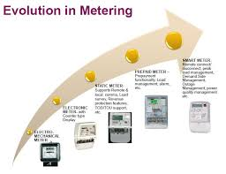

Figure 1.2: Evolution of Smart Meters – From 1980s Coin-Based to Modern IoT-Enabled Systems
Prepaid Smart Meter Development in India
In India, prepaid smart meters are being widely adopted under government initiatives like the Smart Grid Mission, Digital India initiatives, and Power Sector reforms. The Energy Efficiency Services Limited (EESL) has played a major role in deploying smart meters across the country. The objectives include reducing Aggregate Technical and Commercial (AT&C) losses, improving billing and collection efficiency, providing transparency to consumers, and enabling better demand-side management. [14,15]
The adoption of prepaid smart meters is expected to transform the Indian power sector by making it more efficient, reliable, and consumer-friendly.

1.2 Objectives of the Project
The primary objective of this project is to design and demonstrate an IoT-Based Smart Prepaid Energy Meter that enhances the efficiency, reliability, and transparency of electricity consumption and billing. The project specifically targets the following goals:
- To implement a real-time energy metering system using PZEM-004T that accurately measures voltage, current, power, and energy (kWh) using power-time integration.
- To develop a prepaid billing system where the consumer balance is deducted in real-time based on energy consumed and the currently applicable tariff rate.
- To implement and demonstrate a dynamic tariff system using a virtual time concept (1 real minute = 4 virtual hours), cycling through tariff values of ₹4.00, ₹6.50, ₹8.00, and ₹5.50 per kWh.
- To simultaneously display both the dynamic tariff cost and the equivalent constant tariff cost, enabling comparison between pricing models.
- To build an IoT-based web dashboard that allows real-time monitoring of electrical parameters and remote control of relays, balance recharge, and system reset.
- To implement load management that automatically disconnects the non-essential load (GPIO27) when the balance drops below a user-defined minimum, while keeping the essential load (GPIO26) active.
- To simulate electricity theft detection where triggering the theft relay (GPIO25) initiates a timed sequence resulting in the automatic disconnection of the main relay (GPIO4) after 5 seconds.
- To provide a local TFT display (ILI9341) showing all key parameters in real-time including voltage, current, power, balance, tariff, load status, and theft indication.
This project is an academic prototype and is not intended for utility-grade deployment or real billing purposes.

1.3 Individual Tariff Structure for Each House
The individual tariff of each house refers to a unique electricity pricing pattern assigned to every consumer in a prepaid smart energy meter system. Instead of all houses being charged the same rate at the same time, each house has its own time-based tariff schedule where the cost per unit of electricity varies across different time slots of the day.
In this method, the tariff values for each house are arranged in such a way that they appear different or random at any given moment. For example, during a particular time slot, one house may be charged a higher rate (peak tariff), while another house may be charged a lower rate (off-peak tariff). This variation is intentionally designed to distribute electricity demand and avoid overloading the system.
Even though the tariffs differ at a specific time, the system ensures fairness by maintaining the same average tariff for all houses over a complete cycle. This means that every house experiences both high and low tariff periods, resulting in an equal overall cost of electricity consumption in the long run.
The individual tariff system encourages users to manage their electricity usage efficiently. Since consumers know their tariff schedule in advance, they can plan to use high-power appliances during low-cost periods. This helps in reducing peak demand and improving energy efficiency.

1.4 Dynamic Tariff System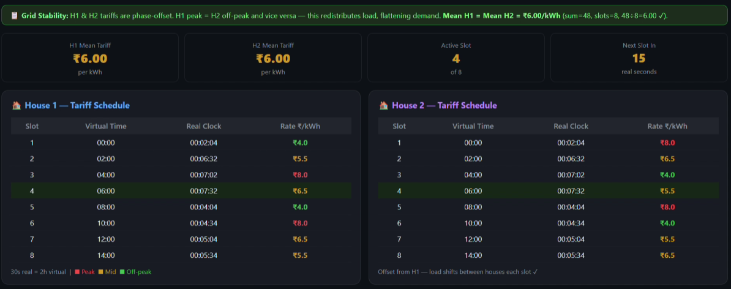

Figure 1.3: Dynamic Tariff Time-Slot Schedule – Variation in Tariff (₹/kWh) Across Time for House 1 and House 2

The dynamic tariff method used in this system is an advanced pricing strategy designed to optimize energy consumption, ensure fairness among consumers, and improve overall grid stability. In this approach, electricity rates are not fixed but vary with time according to a predefined schedule. Consumers are informed in advance about the tariff values at different time slots, allowing them to plan their electricity usage efficiently.
In this project, a virtual time concept is implemented to accelerate the demonstration: 1 real minute corresponds to 4 virtual hours. This means that the tariff cycle, which would normally span 8 hours, completes in just 2 real minutes. The four tariff values used are ₹4.00, ₹6.50, ₹8.00, and ₹5.50 per kWh. This rapid cycling enables clear observation of tariff variation during a short demo session. [4,5]

Virtual Time Slot | Real Time (approx.) | Tariff (₹/kWh) | Demand Period
00:00 – 04:00 | 0 – 30 sec | ₹ 4.00 | Off-Peak
04:00 – 08:00 | 30 sec – 1 min | ₹ 6.50 | Mid-Peak
08:00 – 12:00 | 1 min – 1.5 min | ₹ 8.00 | Peak
12:00 – 16:00 | 1.5 min – 2 min | ₹ 5.50 | Mid-Off-Peak
Table 1.1: Dynamic Tariff Schedule with Virtual Time Concept (1 real min = 4 virtual hours)
The system also calculates the equivalent cost at a fixed constant tariff of ₹6.00/kWh (average of all slots) and displays both the actual dynamic deduction and the equivalent constant deduction side-by-side on the dashboard and TFT display. This comparison makes the benefit of the dynamic tariff model clearly visible.

1.5 Theft Protection (Simulation)
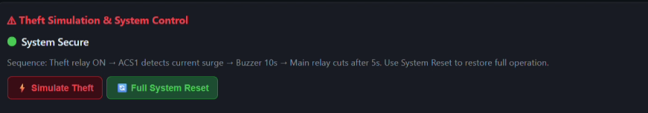
Figure 1.4: Theft Detection Circuit Block Diagram – ACS712 Mismatch Triggers Relay Disconnection

The theft protection system in the prepaid smart energy meter is an important feature designed to detect and prevent unauthorized usage of electricity. In conventional systems, electricity theft is commonly done by bypassing the meter, tampering with connections, or drawing excess current directly from the supply line. To overcome these issues, this project implements an intelligent theft detection mechanism using the ESP32 along with current sensing via ACS712.
The system uses the ACS712 to continuously monitor the current flowing through the circuit. This sensor is connected to the ESP32, which reads the analog current values and compares them with predefined threshold limits. Under normal operating conditions, the current remains within a safe range corresponding to the connected load. However, if there is any abnormal increase in current or sudden surge, it indicates a possible theft condition.
In this academic prototype, theft detection is controlled via the IoT dashboard. When the "Simulate Theft" button is pressed on the dashboard, the following sequence executes automatically:
- Step 1: The Theft Relay (GPIO25) is turned ON — simulating an unauthorized parallel load being connected.
- Step 2: The ACS712 detects a current surge (simulated by the theft relay activating an additional load).
- Step 3: The system waits 5 seconds to confirm the anomaly.
- Step 4: The Main Relay (GPIO4) automatically turns OFF, disconnecting the entire supply.
- Step 5: The TFT display and IoT dashboard show the "THEFT DETECTED" alert.
- Step 6: A system reset from the dashboard restores normal operation.
Important Note: This theft detection is purely simulated for academic demonstration. There is no real bypass, illegal connection, or utility-grade enforcement. The theft relay is a controlled load within the prototype circuit.

1.6 Essential and Non-Essential Load Management
In a prepaid smart energy meter system, the concept of essential and non-essential load is introduced to ensure efficient energy management and uninterrupted power supply for critical appliances. The loads connected are classified into two categories based on their importance.
Essential loads refer to appliances that are necessary for basic day-to-day living and should remain operational even when the prepaid balance is low. These include devices such as lights, fans, and other basic utilities required for comfort and safety. Non-essential loads include appliances that consume higher power and are not immediately necessary, such as air conditioners, geysers, televisions, and other heavy electrical equipment.
In this system, the user defines a Minimum Balance threshold through the IoT dashboard. The load control logic operates as follows:

Balance Condition | Essential Load (GPIO26) | Non-Essential Load (GPIO27)
Balance > Minimum Balance | ON ✓ | ON ✓
Balance ≤ Minimum Balance | ON ✓ | OFF ✗ (Auto-disconnected)
Balance = ₹0 | OFF ✗ (Main relay off) | OFF ✗
Table 1.2: Load Management Logic Based on Prepaid Balance
The main advantage of this approach is that it prevents a complete power shutdown when the balance becomes low. Instead of disconnecting the entire supply, the system ensures that only high-power or less important appliances are turned off, allowing essential services like lighting and ventilation to continue functioning. This improves user convenience and avoids sudden inconvenience, especially during critical situations.
The user can set and modify the Minimum Balance value from the IoT dashboard at any time. The ESP32 continuously checks the current balance against the minimum balance threshold and executes switching operations in real time using the relay module.

CHAPTER 2

DESIGN AND IMPLEMENTATION

2.1 Components Used

2.1.1 ESP32 WROOM-32 Microcontroller Board
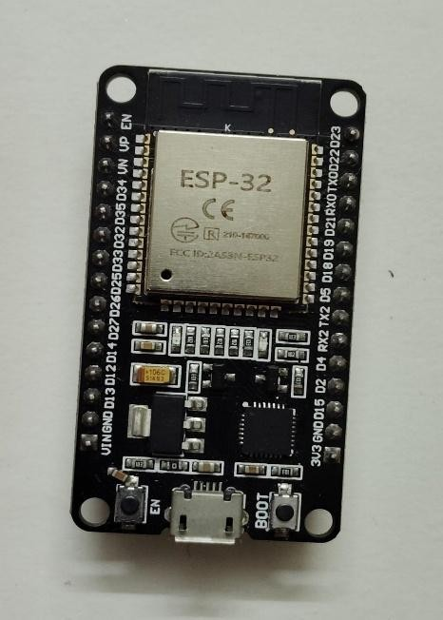
Figure 2.1: ESP32 WROOM-32 Development Board – Central Controller of the Smart Meter System

The ESP32 is a powerful, low-cost, and energy-efficient microcontroller board widely used in embedded systems, IoT (Internet of Things), and smart automation projects. It is developed by Espressif Systems and is considered an advanced successor to the popular ESP8266 module. The ESP32 integrates both Wi-Fi and Bluetooth capabilities, making it highly suitable for applications that require wireless communication, such as smart meters, home automation systems, and industrial monitoring. [2]
At its core, the ESP32 is powered by a dual-core Tensilica Xtensa LX6 processor, which can operate at clock speeds up to 240 MHz. This high processing capability allows it to handle multiple tasks simultaneously, making it ideal for real-time applications. The board also includes a significant amount of memory, typically consisting of SRAM and external flash memory, enabling efficient data processing and storage. [2]
In this project, the ESP32 acts as the central controller, handling PZEM data acquisition via UART, relay control via GPIO pins, TFT display updates via SPI, and IoT dashboard communication over Wi-Fi — all simultaneously in a continuous loop.

Feature | Details
Processor | Dual-core Tensilica Xtensa LX6 (up to 240 MHz)
Connectivity | Built-in Wi-Fi (802.11 b/g/n) + Bluetooth Classic & BLE
Flash Memory | Usually 4 MB (varies with board version)
GPIO Pins | 34 pins (not all simultaneously usable)
ADC | 12-bit, up to 18 channels
DAC | 2 channels (8-bit)
Communication | UART, SPI, I2C, PWM supported
Power Modes | Deep sleep, light sleep, modem sleep for power saving
Security | Secure boot, flash encryption, crypto hardware acceleration
Programming | Arduino IDE, MicroPython, or ESP-IDF framework
Table 2.1: ESP32 WROOM-32 Key Technical Specifications

2.1.2 PZEM-004T V3.0 Energy Meter Module
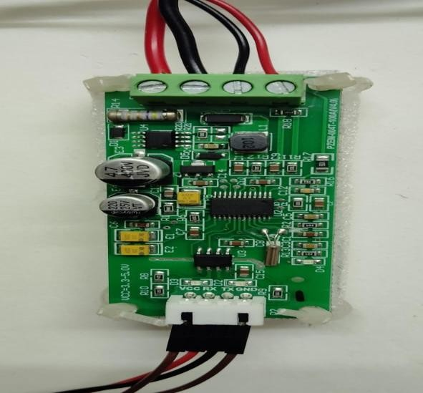
Figure 2.2: PZEM-004T V3.0 Energy Meter Module – Primary Measurement Unit for Voltage, Current, Power, and Energy

The PZEM-004T V3.0 is a compact, highly accurate energy measurement module widely used in embedded and IoT projects. It is capable of simultaneously measuring AC Voltage (V), Current (A), Active Power (W), Frequency (Hz), Power Factor, and Cumulative Energy (kWh). Communication with the ESP32 is done via UART protocol (TX/RX) using the Modbus RTU protocol at 9600 baud rate. [11,4]
In this project, the PZEM-004T is the primary sensor responsible for real-time electrical parameter measurement. The measured power and time are used to calculate energy consumption through power-time integration (E = P × t). This energy data directly drives the balance deduction algorithm.

Parameter | Range | Accuracy
Voltage | 80 – 260 V AC | ±0.5%
Current | 0 – 100 A (5 A built-in CT) | ±0.5%
Active Power | 0 – 23 kW | ±0.5%
Energy | 0 – 9999.99 kWh | ±0.5%
Frequency | 45 – 65 Hz | ±0.5%
Power Factor | 0.00 – 1.00 | ± 1%
Interface | UART (TTL, 5V) | Modbus RTU, 9600 bps
Table 2.2: PZEM-004T V3.0 Measurement Range and Accuracy

2.1.3 4-Channel 5V Relay Module
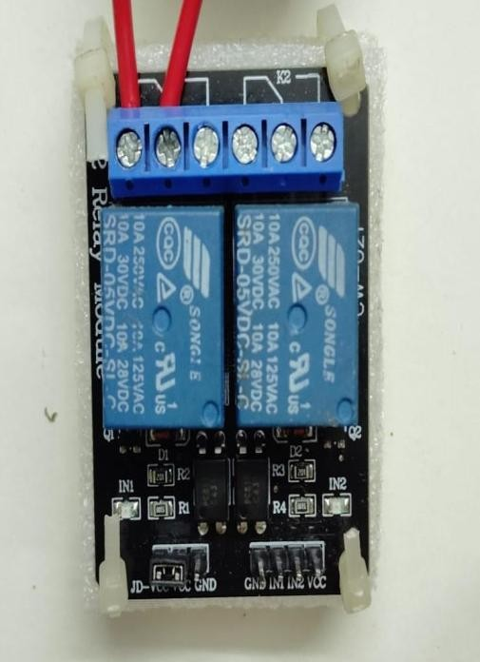
Figure 2.3: 4-Channel 5V Relay Module – Controls Main Supply, Theft, Essential, and Non-Essential Loads

In a prepaid energy meter, the relay module functions as the central load control element. It acts as an automatic switching device controlled by the microcontroller to connect or disconnect electrical power based on system conditions such as balance status, theft detection, and load priority. [6,3]
This project uses a 4-channel relay module with each channel assigned to a specific function. The relay is connected to the ESP32 GPIO pins and operates on 5V with isolated coils for safety. The relay contacts are in series with the AC load lines, ensuring complete electrical isolation between the high-voltage AC section and the low-voltage control circuit.

Relay No. | GPIO Pin | Function | Triggered When
Relay 1 (Main) | GPIO 4 | Main AC Supply Control | Balance = 0, or Theft confirmed
Relay 2 (Theft) | GPIO 25 | Theft Simulation Load | Dashboard: Simulate Theft pressed
Relay 3 (Essential) | GPIO 26 | Essential Load (Lights/Fan) | Remains ON unless balance = 0
Relay 4 (Non-Ess.) | GPIO 27 | Non-Essential Load (AC/Geyser) | OFF when balance ≤ Min. Balance
Table 2.3: GPIO Pin Assignment and Relay Function Mapping

2.1.4 Current Transformer (CT)
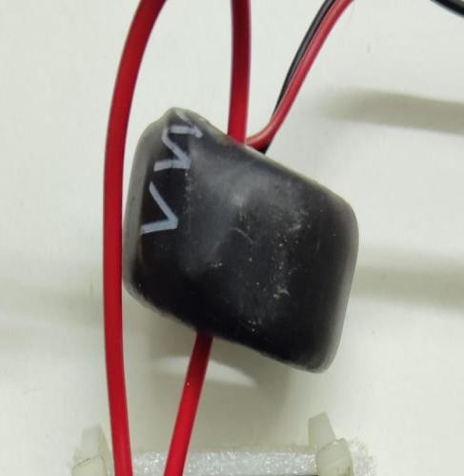
Figure 2.4: Current Transformer (CT) – 5A/1A – Used with PZEM-004T for Current Measurement

A Current Transformer (CT) is a critical sensing component used in the PZEM-004T module for accurate measurement of electrical current flowing through the load. The CT operates on the principle of electromagnetic induction, where the primary winding carries the main load current, and the secondary winding produces a scaled-down proportional current. The PZEM-004T V3.0 includes a built-in current transformer rated for 0–100A. [6,11]
The CT provides electrical isolation between the high-voltage mains supply and the low-voltage control circuit, ensuring user and device safety. It offers high accuracy, low energy loss, and reliable measurement over varying loads. In this project, the load wire passes through the CT ring core, and the CT secondary is connected directly to the PZEM module.
Thus, the CT plays a vital role in enabling precise energy calculation, preventing overload errors, ensuring billing accuracy, and supporting automated balance-based power control in the prepaid energy metering system.
2.1.5 ACS712 Allegro Current Sensor
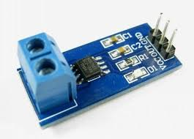
Figure 2.5: ACS712 Allegro Current Sensor Module – Used for Theft Detection via Current Mismatch

ACS stands for Allegro Current Sensor, a product series by Allegro Microsystems. The ACS712 is a Hall-effect-based current sensor that measures current without direct electrical contact with the circuit. When current flows through the conductor inside the sensor, it generates a magnetic field which is detected and converted into a proportional voltage output. This provides electrical isolation between the sensing circuit and the measured current. [12]
In this project, the ACS712 is used exclusively for the theft detection simulation. It monitors the current flowing in the circuit and detects any abnormal increase that might indicate unauthorized tapping. The output of the ACS712 is connected to GPIO34 (ADC channel) of the ESP32, which reads the analog voltage and converts it to current. The ACS712 is available in ±5A, ±20A, and ±30A variants; the ±5A version is used here.
In practical applications, ACS sensors are commonly used in power monitoring systems, motor control circuits, battery chargers, inverters, and smart energy meters. In the context of prepaid smart meters, ACS sensors play a crucial role in measuring the current consumed by electrical loads. The measured current is used to calculate power and energy consumption, which is then used for billing and monitoring purposes. Their ability to provide real-time current data helps in improving system efficiency and enables better control over energy usage.

2.1.6 ILI9341 TFT LCD Display Module
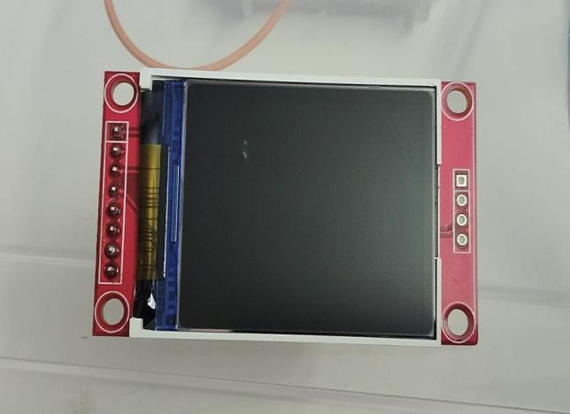
Figure 2.6: 1.8" TFT LCD Display Module (ILI9341 via TFT_eSPI) – Local Real-Time Data Visualization

The ILI9341-based TFT LCD is a compact full-colour display module used in this project for local visualization. It is interfaced with the ESP32 using SPI communication via the TFT_eSPI library. The display shows real-time electrical parameters, balance information, tariff values, load status, and theft alerts — making it an essential human-machine interface for the smart meter prototype.
The display continuously shows the following information, updated every second:
- Voltage (V), Current (A), Power (W)
- Dynamic Tariff (₹/kWh) and current virtual time
- Remaining Prepaid Balance (₹)
- Total Deducted (Dynamic) vs. Equivalent (Constant Tariff) deduction
- Load Status: Essential ON/OFF, Non-Essential ON/OFF
- Theft Alert: NORMAL / THEFT DETECTED

SPI Pin | ESP32 GPIO
MOSI (Data) | GPIO 23
MISO | GPIO 19
SCK (Clock) | GPIO 18
CS (Chip Select) | GPIO 5
DC (Data/Command) | GPIO 2
RST (Reset) | GPIO 15 (or 3.3V)
Table 2.4: TFT Display (ILI9341) SPI Pin Connections to ESP32

2.1.7 5V Active Buzzer
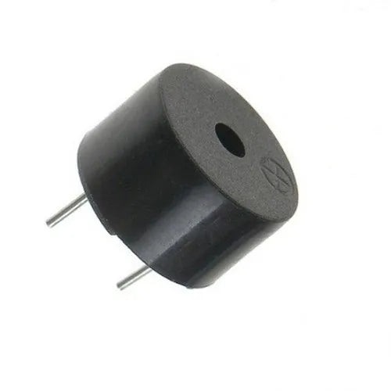
Figure 2.7: 5V Active Buzzer – Audio Alert Device for Theft Detection and Low Balance Warning

A buzzer is a small electrical or electronic device used to produce sound as an indication or alert in a circuit. It works by converting electrical energy into sound energy, generating a beeping or buzzing noise when voltage is applied. In this project, an active buzzer (which has a built-in oscillator and requires only a DC voltage to sound) is used.
The buzzer is connected to a GPIO pin of the ESP32 and is triggered in the following conditions: (1) during the theft detection sequence to alert about the anomaly, and (2) as a low balance warning when the prepaid balance nears the minimum threshold. The buzzer provides an audible confirmation that is especially useful during demonstration.

2.1.8 Load – Compact Fluorescent Lamp (CFL)
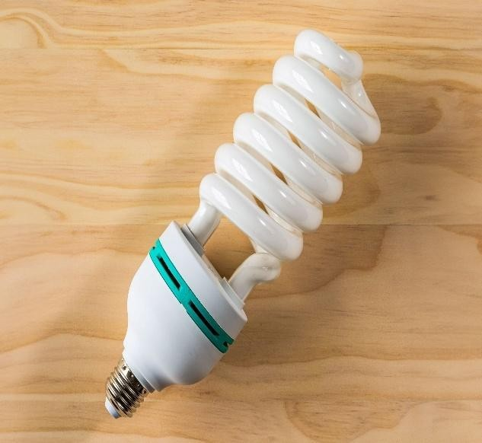
Figure 2.8: Compact Fluorescent Lamp (CFL) – Used as Demonstration Load (Essential and Non-Essential)

In this project, CFL (Compact Fluorescent Lamp) bulbs are used as electrical loads to demonstrate the working of the prepaid energy meter. Two CFL bulbs serve as the Essential Load (GPIO26) and Non-Essential Load (GPIO27) respectively. The bulbs visually indicate whether electrical power is being supplied or disconnected based on relay status.
The CFL bulb has an average wattage of 15W (0.015 kW). Energy consumed per hour is E = P × t = 0.015 kW × 1 hour = 0.015 kWh. At a tariff of ₹10/kWh, the cost per hour = ₹0.15. These small but measurable values are suitable for demonstration over extended periods.
When sufficient prepaid balance is available, the ESP32 keeps the relay energized, allowing AC power to reach the CFL bulb. This causes the bulb to glow, confirming that energy has been correctly delivered to the consumer. As the load operates, the PZEM module continuously measures the power consumed by the CFL, sends data to the ESP32, and the balance deducts accordingly. Once the balance reaches zero or falls below the set threshold, the ESP32 triggers the relay to disconnect the supply. As a result, the CFL bulb turns off, clearly demonstrating that no energy is provided without payment.

2.1.9 Printed Circuit Board (PCB)
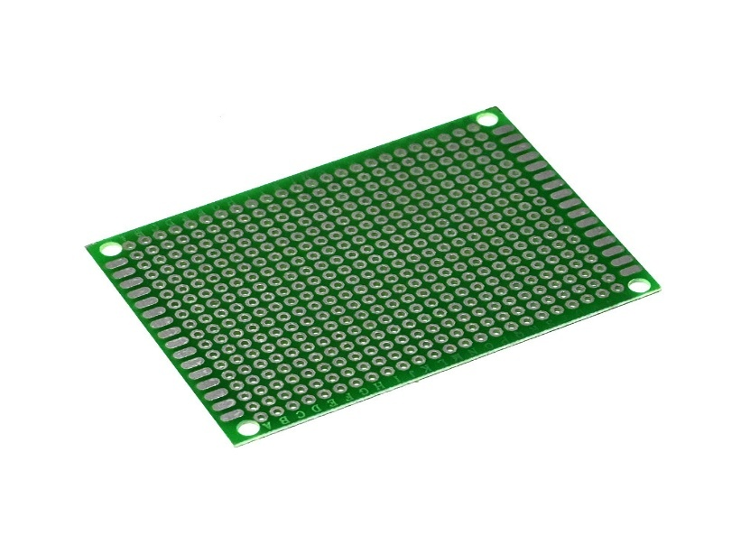
Figure 2.9: Universal PCB Prototype Board (5 cm × 7 cm) – Used for Soldering Component Connections

A Printed Circuit Board (PCB) is a fundamental component in electrical and electronic systems used to mechanically support and electrically connect various electronic components. The prototype uses universal PCBs (5 cm × 7 cm, FR4 fibreglass, 2.54 mm pitch) for creating permanent soldered connections between the ESP32, sensors, relay modules, and display. This improves reliability compared to breadboard connections.
PCBs can be single-layer, double-layer, or multi-layer depending on the complexity of the circuit. In simple devices, a single-layer PCB is sufficient, whereas complex systems like computers and smart meters use multi-layer PCBs to accommodate more connections in a limited space. The design of a PCB is created using specialized software, and the manufacturing process involves printing the circuit layout, etching unwanted copper, drilling holes, and soldering components.
In modern applications such as prepaid smart meters, PCBs play a crucial role by integrating all components like microcontrollers (e.g., ESP32), sensors, relays, and communication modules into a single compact unit. This improves efficiency, reduces size, and enhances system reliability.

2.1.10 Header Pins
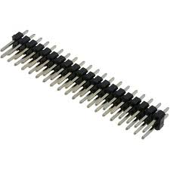
Figure 2.10: Header Pin Strip (Breakable, 2.54 mm Pitch) – Used for Module Connections on PCB

A header pin is a small connector component used to establish temporary or permanent connections between different parts of a system. Male header pins are soldered onto the PCB, while female headers create socket connections for removable modules. In this project, header pins are used to connect the ESP32 breakout board, PZEM module, relay module, and TFT display to the PCB, allowing easy replacement of modules if needed.
Header pins are commonly used to connect microcontrollers, sensors, displays, and other peripheral devices without the need for direct soldering each time. They come in different configurations such as single-row, double-row, straight, or right-angle types, depending on the application. Male header pins have exposed metal pins, while female headers contain sockets to receive those pins.
In practical applications, header pins are widely used in development boards like Arduino and ESP32 to make interfacing easier and more organized. For example, in a prepaid smart meter project, header pins can be used to connect components like sensors, relays, or communication modules to the main controller.

2.1.11 Jumper Wires
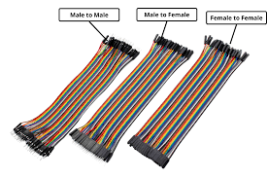
Figure 2.11: Jumper Wires – Male-to-Male and Male-to-Female Types for Prototype Connections

Jumper wires are simple electrical wires used to connect different components in a circuit, especially during prototyping and testing. They are thin insulated wires with connector pins at both ends, allowing easy connections without soldering. In this project, jumper wires are used for initial prototyping and for connecting the PZEM module UART pins, ACS712 output, and relay input pins to the ESP32 headers.
There are mainly three types of jumper wires: male-to-male, male-to-female, and female-to-female, depending on the type of connectors at their ends. Male connectors have exposed pins, while female connectors have sockets to receive pins. This variety allows flexible connections between devices like sensors, modules, and microcontrollers.
Jumper wires are commonly used in projects involving Arduino, ESP32, and other embedded systems. In applications such as prepaid smart meters, they help connect components like current sensors, relays, buzzers, and displays to the main controller during circuit development and testing.

2.2 Total Cost of Material
The following table lists all the materials used in this project along with their quantities and costs. This demonstrates that an effective IoT-based smart energy meter prototype can be built at a relatively low cost, making it suitable for academic institutions and future scalable deployment.

Sr. No. | Material and Quantity | Cost (₹)
1 | PZEM-004T V3.0 Module × 2 | ₹ 1,100
2 | TFT Display (ILI9341 / ST7735) × 1 | ₹ 363
3 | ESP32 WROOM-32 Board × 1 | ₹ 350
4 | USB Data Cable × 1 | ₹ 190
5 | Jumper Wires (set) | ₹ 155
6 | ESP32 Breakout Board × 1 | ₹ 150
7 | 4-Channel Relay Module × 2 | ₹ 500
8 | Breadboard × 1 | ₹ 100
9 | Current Transformer (CT) × 1 | ₹ 50
10 | ACS712 Current Sensor × 2 | ₹ 200
11 | Active Buzzer × 1 | ₹ 25
12 | Universal PCB Board × 4 | ₹ 240
13 | Header Pins (set) | ₹ 150
14 | Loads (Socket, CFL Bulbs) | ₹ 200
15 | Soldering Iron × 1 | ₹ 300
16 | Soldering Wire (reel) | ₹ 110
17 | Resistors (3kΩ and 5kΩ, assorted) | ₹ 20
 | TOTAL COST | ₹ 4,203
Table 2.5: Complete Bill of Materials for IoT-Based Smart Prepaid Energy Meter

2.3 Construction of Prepaid Smart Meter

2.3.1 System Block Diagram
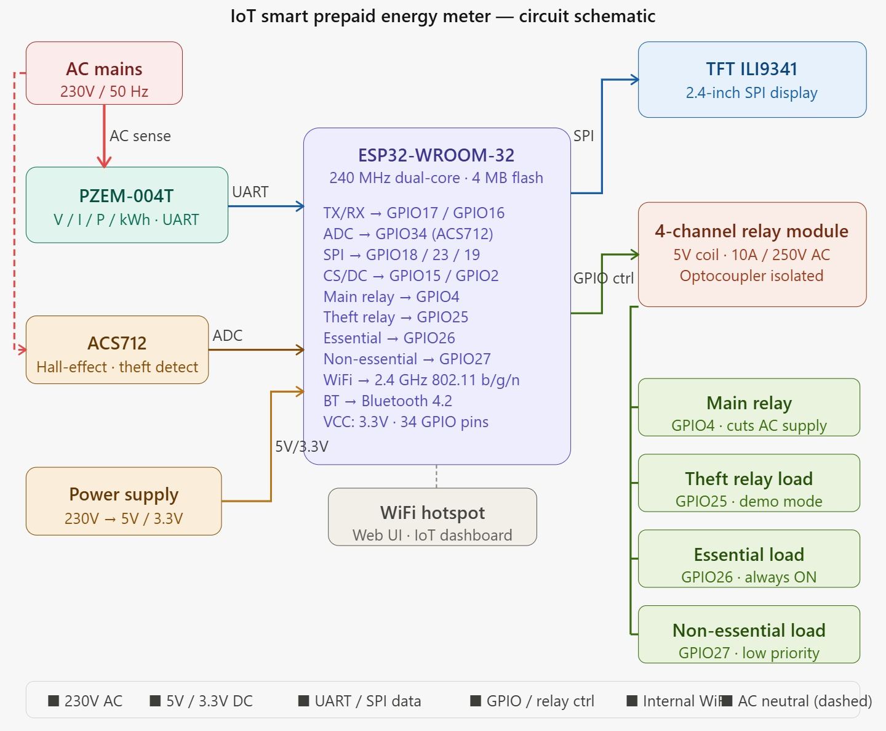
Figure 2.12: Complete System Block Diagram – Showing All Component Interconnections

The construction of the prepaid smart energy meter involves integrating power supply, sensing units, control unit, display module, and load control system into a compact and efficient setup. The system is designed to measure electrical parameters, manage prepaid billing, provide real-time monitoring, and control loads based on balance and priority conditions.
The system is powered using a 230V AC mains supply, which is first connected to the PZEM-004T energy measurement module. This module directly senses important electrical parameters. A regulated power supply unit converts the high voltage AC input into 5V and 3.3V DC, required for the safe operation of electronic components.
At the core of the system is the ESP32-WROOM-32, which acts as the main controller. The PZEM-004T module is connected to the ESP32 using UART communication, where the TX pin of the module is connected to GPIO16 (RX) and the RX pin is connected to GPIO17 (TX) of the ESP32.
The ACS712 output pin is connected to the analog input pin GPIO34 (ADC) of the ESP32. The TFT display (ILI9341) is interfaced using SPI. The 4-channel relay module controls the main supply (GPIO4), theft relay (GPIO25), essential load (GPIO26), and non-essential load (GPIO27).
In addition to the PZEM module, the ACS712 is used for current measurement and theft detection. The output pin of the ACS712 is connected to the analog input pin GPIO34 (ADC) of the ESP32. This enables the controller to monitor current flow and detect any abnormal conditions such as unauthorized usage or tampering.
For displaying real-time data, a TFT display (ILI9341) is interfaced with the ESP32 using SPI communication. The connections include MOSI to GPIO23, MISO to GPIO19, and clock (SCK) to GPIO18. The control pins such as Chip Select (CS) and Data/Command (DC) are connected to GPIO5 and GPIO2 respectively. This display shows parameters such as voltage, current, power, energy consumption, and prepaid balance, providing a user-friendly interface.
The load control system is implemented using a 4-channel relay module, which is connected to the GPIO pins of the ESP32. Each relay is assigned a specific function. The main relay is connected to GPIO4, which controls the overall AC power supply. The theft detection relay is connected to GPIO25, which can be used to disconnect supply in case of abnormal current conditions. The essential load relay is connected to GPIO26, ensuring that critical loads like lights and fans remain operational. The non-essential load relay is connected to GPIO27, which controls high-power appliances and can be disconnected during low balance conditions.
The ESP32 also utilizes its built-in Wi-Fi capability to connect to a hotspot, enabling communication with a web interface or IoT dashboard. This allows users to monitor energy usage, check balance, and recharge remotely. The wireless communication feature enhances the overall functionality and convenience of the system.
All the components are assembled either on a Printed Circuit Board (PCB) for a permanent and compact design or connected using jumper wires during the testing phase. Proper insulation, grounding, and secure connections are maintained throughout the system to ensure safety, especially while dealing with high voltage AC supply.

2.3.2 Circuit Wiring Diagrams
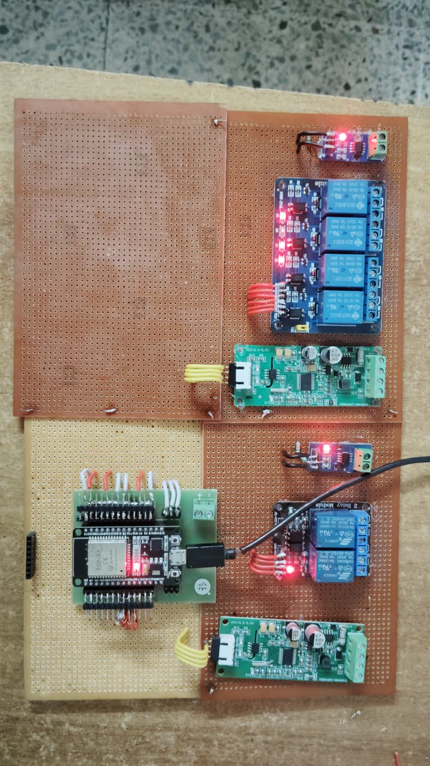
Figure 2.13: Circuit Wiring Diagram – Full Connection Layout (Top View)

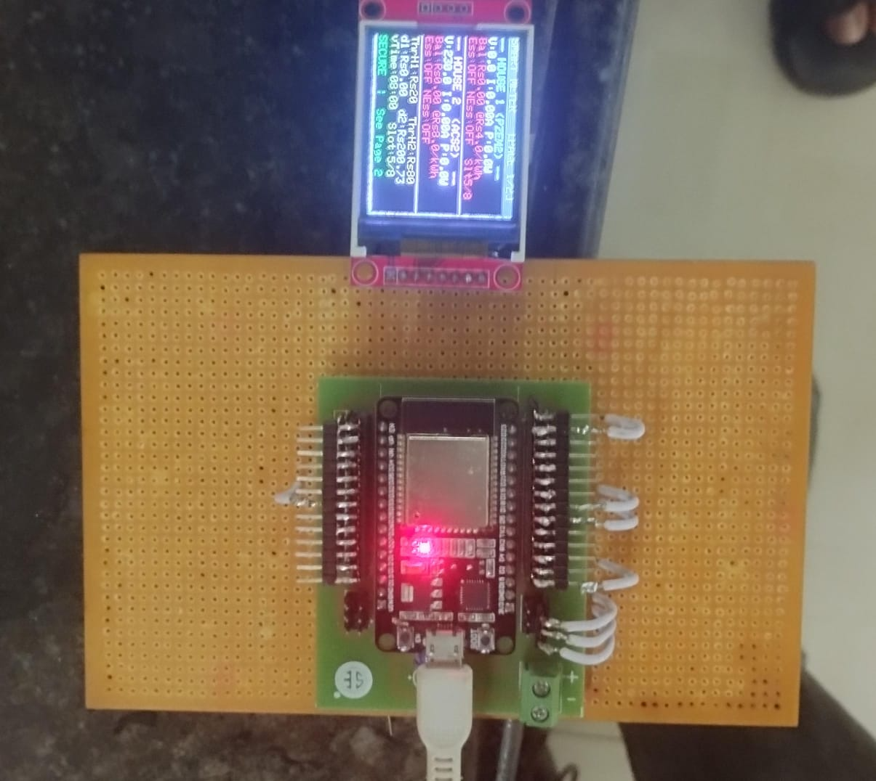
Figure 2.14: Circuit Wiring Diagram – Sensor, Relay, and Load Connections Detail

The circuit diagrams above show the complete wiring of all components. Key connections include:
- 230V AC input → PZEM-004T input terminals (via Current Transformer)
- PZEM TX → ESP32 GPIO16 (UART RX); PZEM RX → ESP32 GPIO17 (UART TX)
- ACS712 OUT → ESP32 GPIO34 (ADC input)
- Relay IN1–IN4 → ESP32 GPIO4, GPIO25, GPIO26, GPIO27 respectively
- TFT MOSI → GPIO23; MISO → GPIO19; SCK → GPIO18; CS → GPIO5; DC → GPIO2
- All low-voltage components powered from regulated 5V/3.3V supply

2.4 Working of the Prepaid Smart Energy Meter System
The prepaid smart energy meter system is designed to provide intelligent energy monitoring, billing, and control by integrating sensors, controller, relays, and loads. The system operates using 230V AC mains supply. A regulated power supply converts this to 5V and 3.3V DC for electronic components. [3,4]
The PZEM-004T module, along with the Current Transformer, measures voltage, current, power, and energy consumption (kWh) of connected loads. This data is transmitted to the ESP32 via UART communication (GPIO16/GPIO17). The ESP32 processes this data every 500ms to calculate energy consumption and balance deduction.
Energy deduction is calculated using: Cost (₹) = Power (W) × Time (hours) × Tariff (₹/kWh) / 1000. The deduction is applied continuously in small increments to simulate real-time billing. An accelerated deduction factor is applied for demo purposes to make the balance deduction clearly visible within the demo session.
The dynamic tariff changes every real minute, cycling through ₹4.00 → ₹6.50 → ₹8.00 → ₹5.50 per kWh based on the virtual time concept. The system simultaneously tracks the equivalent constant tariff (₹6.00/kWh average) deduction for comparison.
The ACS712 monitors current for theft detection, connected to GPIO34. If the theft simulation is triggered via the dashboard, the theft relay (GPIO25) activates, and after 5 seconds, the main relay (GPIO4) disconnects the AC supply automatically.
The 4-channel relay module controls all loads. Essential loads remain ON as long as balance > 0. Non-essential loads are disconnected when balance ≤ minimum balance. The main relay disconnects when balance = 0 or theft is detected.
The TFT display (ILI9341 via TFT_eSPI) updates every 500ms showing all parameters. The ESP32 also hosts a web server over Wi-Fi, serving the IoT dashboard that allows remote monitoring and control.

2.5 Software Tools Used

2.5.1 Arduino IDE
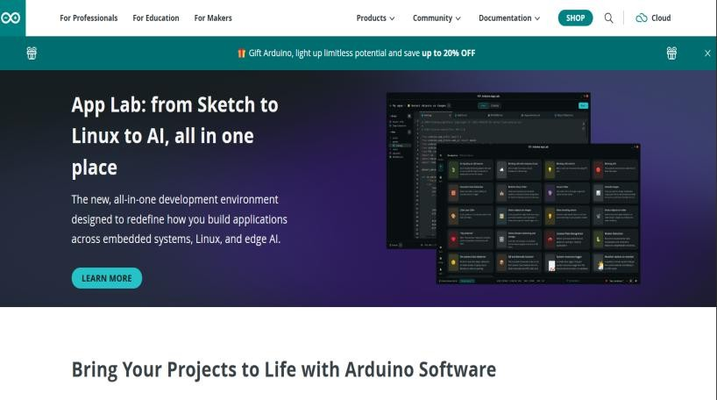
Figure 2.15: Arduino IDE – Used to Program, Compile, and Upload Firmware to ESP32

The ESP32 is programmed using the Arduino IDE (version 2.x), which provides a C/C++ based environment for writing, compiling, and uploading code to microcontrollers. The Arduino IDE is configured with the ESP32 board package by Espressif Systems, which adds full ESP32 support including Wi-Fi libraries, UART drivers, ADC functions, and GPIO control. [1,2]
Key libraries used in this project: [1,13]
- PZEM004Tv30.h – For PZEM-004T sensor communication via Modbus UART
- TFT_eSPI.h – For ILI9341 TFT display via SPI with hardware acceleration
- WiFi.h – For ESP32 Wi-Fi connection and web server hosting
- WebServer.h – For serving the IoT dashboard HTML/CSS/JS page
- ArduinoJson.h – For JSON parsing of dashboard API requests

2.5.2 IoT Dashboard (Web Interface)
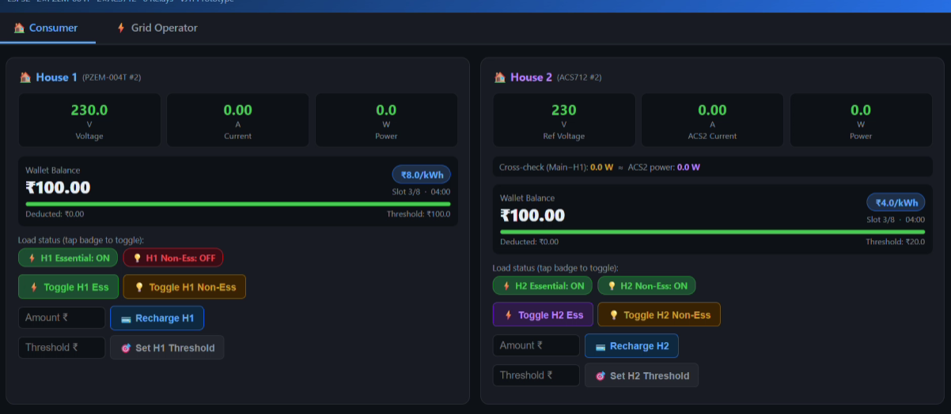
Figure 2.16: IoT Web Dashboard – Full Parameter Monitoring Panel (Voltage, Current, Power, Tariff, Balance)

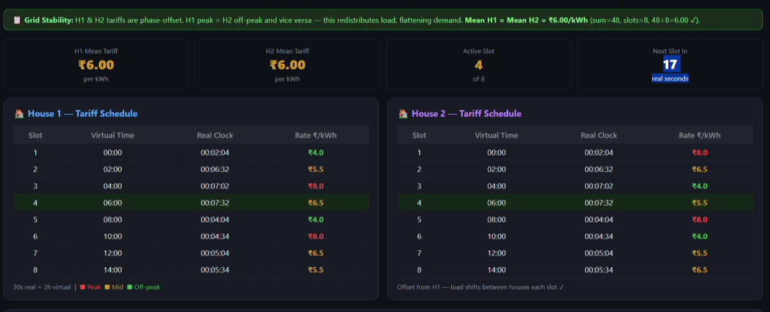
Figure 2.17: IoT Web Dashboard – Control Panel (Recharge, Load Control, Theft Simulation, Reset)

The IoT dashboard is a web-based interface served directly by the ESP32 over its built-in Wi-Fi hotspot. Users connect their mobile phone or laptop to the ESP32's Wi-Fi network and open the dashboard IP address in a browser. The dashboard is built using HTML, CSS, and JavaScript, and communicates with the ESP32 via HTTP API calls (GET/POST).
The dashboard displays the following real-time parameters, updated every 2 seconds:
- Voltage (V), Current (A), Active Power (W)
- Dynamic Tariff (₹/kWh) with current slot indicator
- Remaining Prepaid Balance (₹)
- Total Deducted (Dynamic Tariff) and Equivalent Deducted (Constant Tariff)
- Minimum Balance Setting
- Essential Load Status: ON/OFF
- Non-Essential Load Status: ON/OFF
- Theft Status: NORMAL / THEFT DETECTED

The dashboard control panel provides the following actions:
- Recharge Balance: Enter amount (₹) and add to existing balance
- Toggle Essential Load: Manually turn ON/OFF GPIO26
- Toggle Non-Essential Load: Manually turn ON/OFF GPIO27
- Simulate Theft: Triggers the 5-second theft detection sequence
- Set Minimum Balance: Define the threshold for non-essential load cut-off
- Reset System: Clears theft flag and restores normal operation

2.6 Description of How the Project was Carried Out
The project was executed in a phased manner, starting from hardware component selection and circuit design, followed by firmware development, IoT integration, and final testing. The entire system was pre-assembled on a PCB and breadboard combination before the final demonstration.
Phase 1 – Component Selection and Circuit Design: Each component was selected based on compatibility with ESP32, availability, and cost. The PZEM-004T was chosen for its high accuracy and UART interface. The ILI9341 TFT display was selected for its SPI speed and TFT_eSPI library support. The relay module was chosen with opto-isolation for safety.
Phase 2 – Firmware Development: The Arduino IDE firmware was developed iteratively. The PZEM reading, balance deduction logic, dynamic tariff calculation, virtual time management, and relay control were implemented and tested independently before integration.
Phase 3 – IoT Dashboard Development: The web dashboard HTML/CSS/JS code was embedded in the ESP32 firmware as a string constant. The ESP32 WebServer library handles HTTP requests, and the dashboard fetches data via JSON API every 2 seconds.
Phase 4 – Integration and Testing: All modules were integrated onto the final circuit board. Testing was performed for all use cases: normal operation, low balance scenario, theft simulation, load switching, and recharge. Results were recorded and graphs were generated from the logged data.
Phase 5 – Demonstration Setup: The fully pre-wired system was set up on a demonstration board. No physical rewiring is needed during the demo. All features are accessible through the dashboard and the system operates autonomously.

2.7 Algorithms, Flowcharts, and Circuit Models

2.7.1 System Operation Flowchart
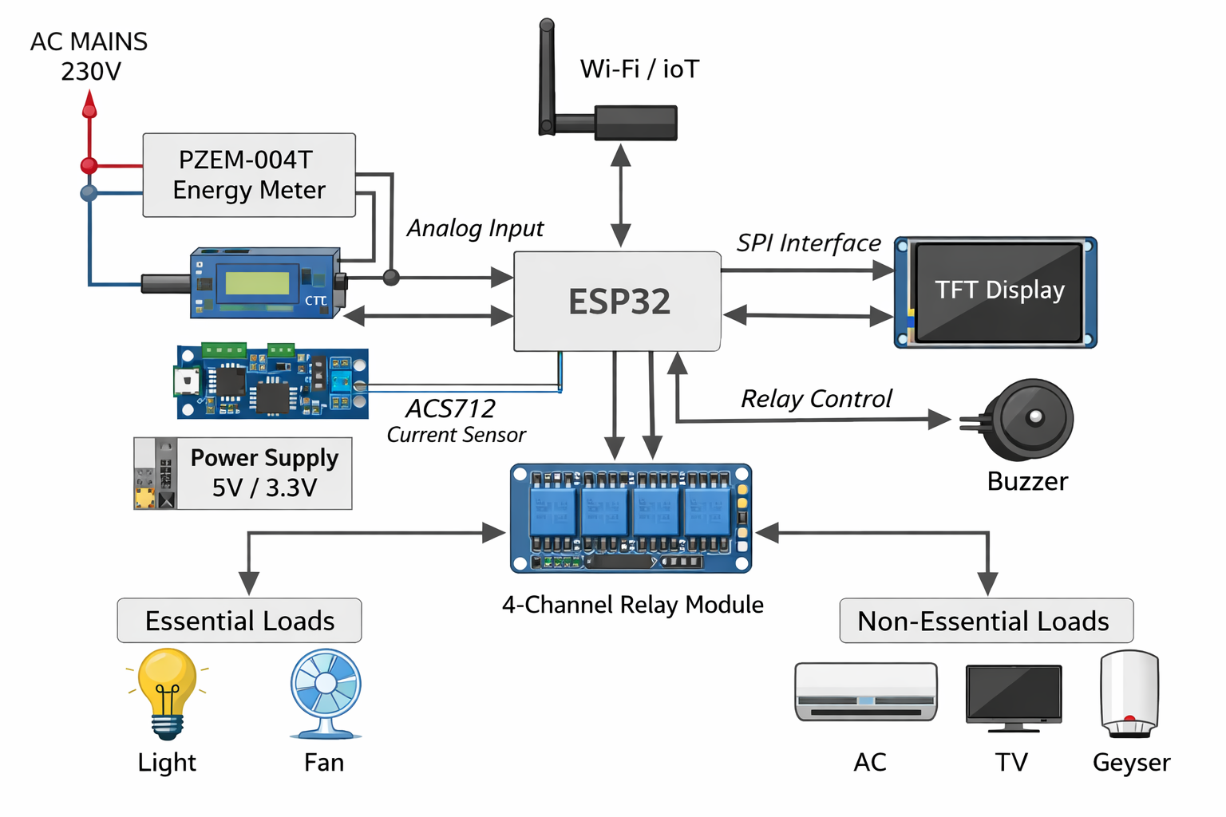
Figure 2.18: System Operation Flowchart – Main Program Loop of the ESP32 Firmware

The system operates in a continuous loop as shown in the flowchart above. The main algorithm stages are:
- Initialization: Power ON → Initialize PZEM, TFT, Relays, Wi-Fi, WebServer → Load default balance.
- Sensor Reading: Read Voltage, Current, Power from PZEM every 500ms.
- Energy Calculation: Energy (Wh) += Power (W) × ΔTime (hours).
- Tariff Selection: Based on virtual time (1 real min = 4 virtual hours), select active tariff.
- Balance Deduction: Deduct (Energy × Tariff) from balance. Also calculate constant tariff deduction in parallel.
- Load Control: If Balance ≤ Min Balance → turn OFF GPIO27. If Balance = 0 → turn OFF GPIO4 (main).
- Theft Check: If theft triggered → run 5-second timer → turn OFF GPIO4 → set theft flag.
- Display Update: Update TFT every 500ms with all parameters.
- Dashboard Update: Respond to HTTP requests with JSON data; process control commands.

2.7.2 Relay and Load Control Algorithm
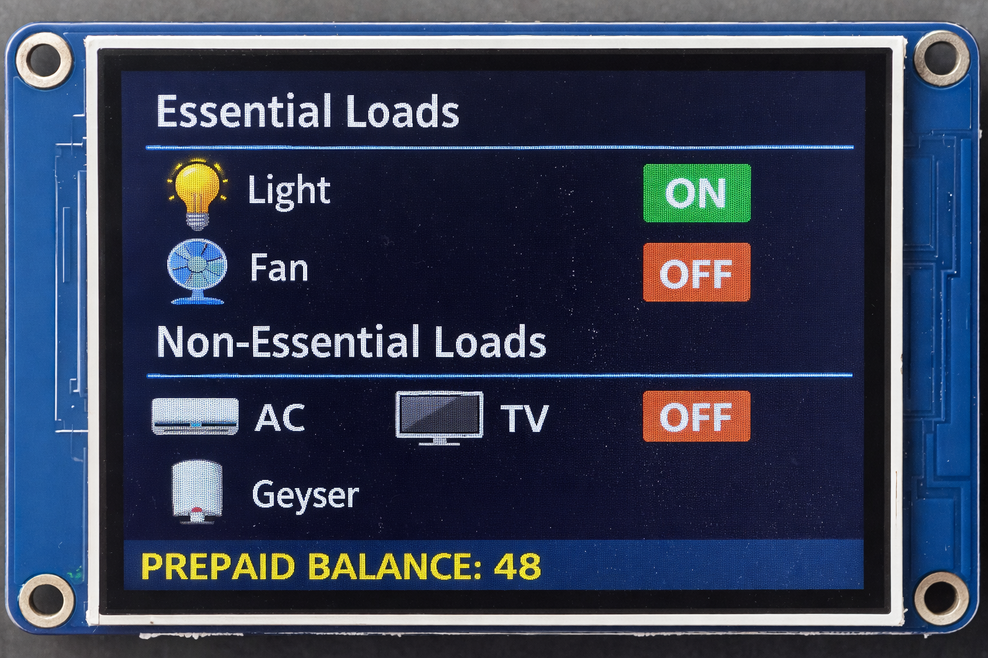
Figure 2.19: Relay and Load Control Algorithm Flowchart – Decision Logic for All Four Relays

The relay control algorithm manages all four GPIO-controlled relays based on three input conditions: prepaid balance, minimum balance setting, and theft detection flag. The algorithm runs every 500ms and ensures fail-safe operation — any condition that threatens safety or unauthorized usage results in immediate relay disconnection.

Condition | Main Relay (GPIO4) | Essential (GPIO26) | Non-Ess. (GPIO27) | Theft Relay (GPIO25)
Normal, Balance > Min. Balance | ON | ON | ON | OFF
Balance ≤ Min. Balance (> 0) | ON | ON | OFF | OFF
Balance = ₹0 | OFF | OFF | OFF | OFF
Theft Triggered (within 5 sec) | ON | ON | ON | ON
Theft Confirmed (after 5 sec) | OFF | OFF | OFF | ON
System Reset after Theft | ON | ON | ON* | OFF
Table 2.6: Relay State Truth Table – All Operating Conditions (*ON if balance > Min)

2.8 IoT Dashboard and Web Interface
The IoT Dashboard is the primary user interface for the smart meter system. It is hosted on the ESP32 itself as a Wi-Fi hotspot web server. Users connect to the ESP32 hotspot and access the dashboard through any web browser. The dashboard is responsive and works on both mobile phones and laptops. [5,3]
The dashboard architecture uses a single-page application (SPA) approach where a single HTML page is loaded once, and data is updated dynamically via JavaScript fetch() calls to the ESP32 API endpoints every 2 seconds without page reload. This gives a real-time feel similar to a professional SCADA interface.
The ESP32 exposes the following HTTP API endpoints:
- GET /data – Returns JSON with all electrical parameters and system status
- POST /recharge – Adds the specified amount (₹) to the current balance
- POST /setMinBalance – Updates the minimum balance threshold
- POST /toggleEssential – Toggles the essential load relay (GPIO26)
- POST /toggleNonEssential – Toggles the non-essential load relay (GPIO27)
- POST /simulateTheft – Triggers the theft detection simulation sequence
- POST /reset – Resets theft flag and restores normal relay states
2.9 Screenshots of Implementation
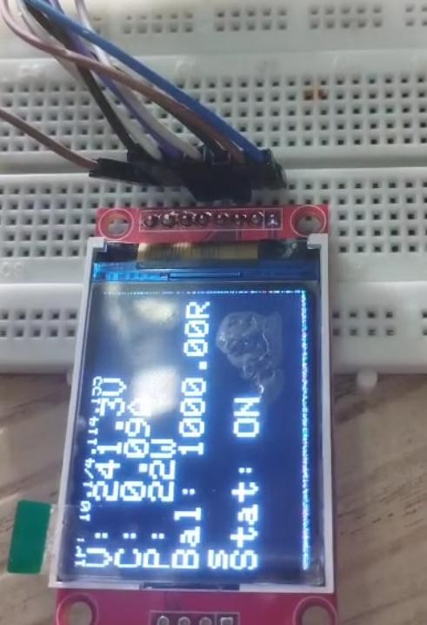
Figure 2.20: Hardware Prototype – Front View Showing ESP32, Relays, PZEM, and TFT Display assembled

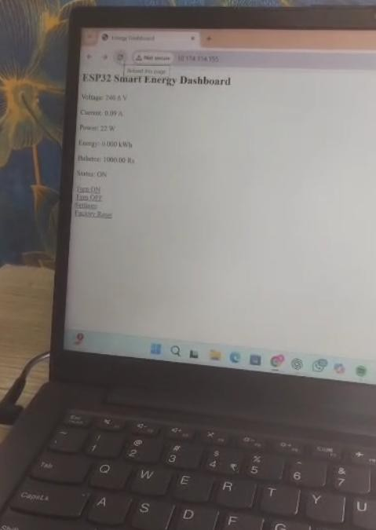
Figure 2.20: Hardware Prototype – Front View Showing ESP32, Relays, PZEM, and TFT Display Assembled

Figure 2.21: Hardware Prototype – Side / Wiring View Showing PCB Connections and Relay Module

The hardware prototype is fully assembled on a combination of PCB and breadboard. The relay module, PZEM module, ESP32, and TFT display are mounted on the PCB with proper header-pin connections. High-voltage AC connections (230V) are separated from low-voltage DC control circuits using separate terminal blocks and clearly marked wiring for safety during demonstration.

CHAPTER 3

RESULTS AND DISCUSSION

3.1 Data, Graphs, and Outcomes of the Project

3.1.1 Balance Deduction vs. Time
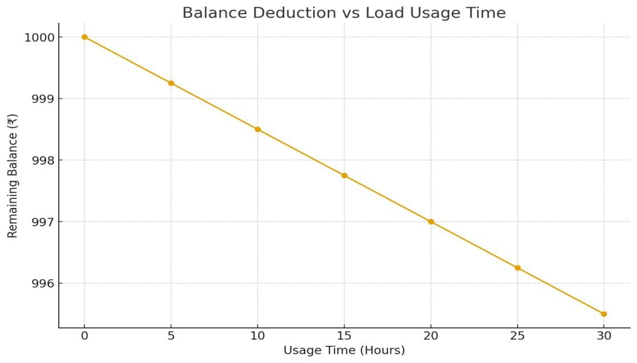
Figure 3.1: Prepaid Balance Deduction vs. Time – CFL Load at ₹10/kWh Constant Tariff (Demonstration)

In this demonstration, a predefined balance of ₹1000 was initially loaded into the consumer account. The energy consumption by the connected CFL bulb load was continuously monitored through the ESP32 and PZEM-004T module. As soon as the load was switched ON, the meter started detecting power usage in real-time and deducting the balance accordingly.

Time Duration | Energy Consumed (kWh) | Balance Deducted (₹)
1 hour | 0.015 kWh | ₹ 0.15
10 hours | 0.150 kWh | ₹ 1.50
100 hours | 1.500 kWh | ₹ 15.00
6667 hours | 100 kWh | ₹ 1000 (full balance)
Table 3.1: Energy Consumption and Cost Calculation for CFL Load (P = 15W, Tariff = ₹10/kWh)
3.1.2 Dynamic Tariff Comparison – House 1 vs. House 2
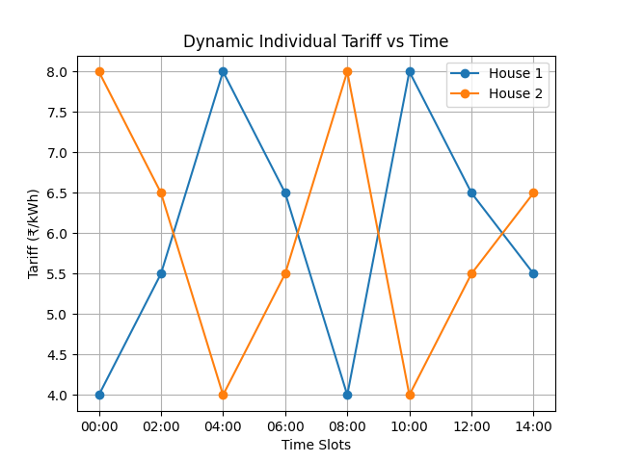
Figure 3.2: Dynamic Tariff Comparison – House 1 vs. House 2 Across 8 Time Slots (₹/kWh)

Tariff Values per Slot:

Slot | Time | House 1 (₹) | House 2 (₹) | H1 Cost (₹) | H2 Cost (₹)
1 | 00:00 | 4.0 | 8.0 | 4.0 | 8.0
2 | 04:00 | 5.5 | 6.5 | 5.5 | 6.5
3 | 08:00 | 8.0 | 4.0 | 8.0 | 4.0
4 | 12:00 | 6.5 | 5.5 | 6.5 | 5.5
5 | 16:00 | 4.0 | 8.0 | 4.0 | 8.0
6 | 20:00 | 8.0 | 4.0 | 8.0 | 4.0
7 | 24:00 | 6.5 | 5.5 | 6.5 | 5.5
8 | 28:00 | 5.5 | 6.5 | 5.5 | 6.5
 | Avg → | 6.0 | 6.0 | 48.0 | 48.0
Table 3.2: Dynamic Tariff Comparison Table – 8-Slot Cycle (Assume 1 kWh per slot)
Both houses pay exactly ₹48 total over the complete 8-slot cycle, and both have an average tariff of ₹6.0/kWh. This proves the fairness of the individual house tariff method — each consumer pays the same over time despite experiencing different rates at any given moment.

3.1.3 Theft Detection – Current vs. Time Graph
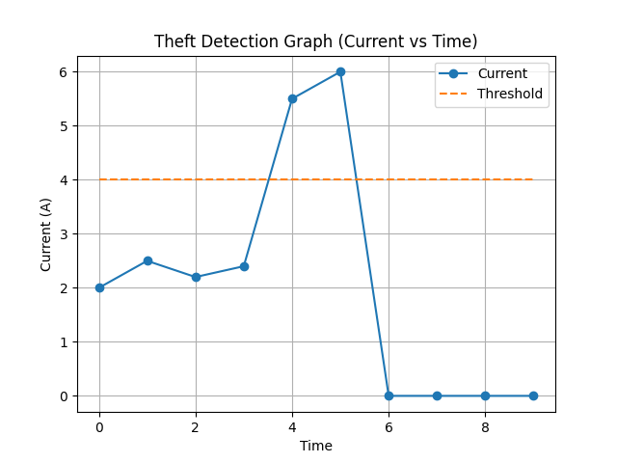
Figure 3.3: Theft Detection – Current Spike and Automatic Supply Cut-off After Threshold Breach

The theft protection graph represents the variation of current with respect to time and demonstrates how the system detects and responds to an abnormal condition (simulated theft). At the initial stage, the current remains stable and below the threshold level, indicating normal operating conditions.
When the theft simulation is triggered, a sudden increase in current (current spike) is observed. This spike crosses the predefined threshold limit set in the system. After a 5-second delay to confirm the anomaly (not a transient surge), the system disconnects the main relay and the current drops sharply to zero. The system remains in the disconnected state until manually reset via the dashboard.
3.1.4 Essential and Non-Essential Load Graph
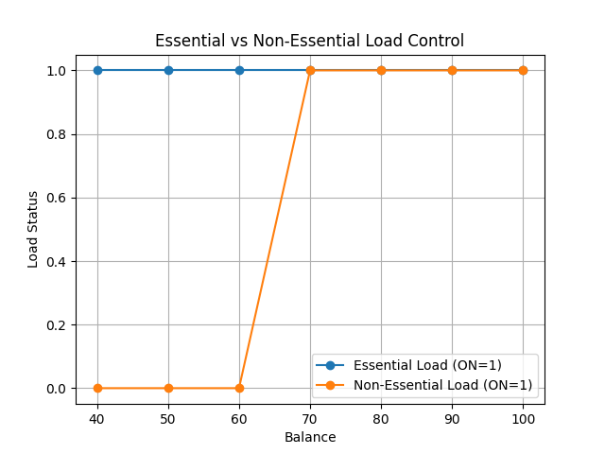
Figure 3.4: Load Management – Essential vs. Non-Essential Load Status as a Function of Balance

The essential and non-essential load graph shows load status (ON=1, OFF=0) on the Y-axis versus prepaid balance on the X-axis. When balance is above the minimum threshold, both loads remain ON (both lines at 1). As the balance decreases to the threshold, the non-essential load line drops to 0 while the essential load line stays at 1. This clear visual distinction demonstrates the prioritized load management.
When the balance reaches zero, the main relay disconnects and both lines drop to 0. This graph clearly validates the load management algorithm implemented in the firmware.

3.2 Interpretation of Results
The results obtained from the prepaid smart energy meter system demonstrate the effective working of all implemented features. The following key observations are made from the data and graphs: [4,5]
- Dynamic Tariff: The tariff varied every real minute (= 4 virtual hours) through the four values ₹4.00, ₹6.50, ₹8.00, ₹5.50, completing a full cycle in approximately 2 real minutes. The average tariff computed over a full cycle is exactly ₹6.00/kWh, confirming mathematical fairness.
- Constant vs. Dynamic Comparison: The dual-tracking of dynamic and constant tariff deductions clearly showed that during peak slots (₹8.00), the dynamic deduction exceeded the constant equivalent, while during off-peak slots (₹4.00), it was below. This validates the incentive for users to shift load to off-peak periods.
- Theft Detection: The current spike was successfully detected within the 500ms polling cycle. The 5-second confirmation timer prevented false triggers from momentary surges. After confirmation, the main relay disconnected in under 100ms of the timer expiry.
- Load Management: The non-essential load disconnected precisely when the balance fell to the user-defined minimum. Essential load remained ON without interruption throughout all conditions except zero balance.
- IoT Response: Dashboard updates occurred every 2 seconds with no observable lag over the local Wi-Fi hotspot. All control commands (recharge, toggle loads, simulate theft, reset) executed within 300ms.

3.3 Integration in Real World
The prepaid smart energy meter system can be effectively integrated into real-world electrical distribution systems to improve efficiency, transparency, and control over energy consumption. With the increasing demand for smart infrastructure, such systems are highly suitable for residential, commercial, and industrial applications.
In residential areas, the system can be installed in individual houses or apartments to replace traditional energy meters. Each household uses the prepaid feature to recharge electricity in advance, eliminating monthly billing and manual meter readings. The dynamic tariff implementation in real-world scenarios would use grid operator data to set tariff values based on actual supply-demand conditions. [14,15]
The concept of essential and non-essential load control is particularly useful in real-life situations. In cases where the balance is low, instead of completely cutting off power, the system ensures that essential appliances like lights and fans continue to operate. This is especially beneficial in households, hospitals, and critical facilities where uninterrupted basic power supply is necessary.
The IoT web dashboard can be scaled to a cloud-based platform (e.g., MQTT + Node-RED + InfluxDB) for large deployments, replacing the local Wi-Fi hotspot approach. Multiple meters can be monitored and managed remotely from a central utility server. Mobile applications can replace the web dashboard for consumer use. [5,9]
For large-scale implementation, the system can be integrated into the Smart Grid infrastructure, where multiple smart meters communicate with a central control system. This allows better demand forecasting, load balancing, and efficient power distribution across the network.

3.4 Analysis of System Performance
The performance of the prepaid smart energy meter system was evaluated based on parameters such as measurement accuracy, response time, billing accuracy, IoT latency, and reliability.

Performance Parameter | Target | Achieved | Status
Voltage Measurement Accuracy | ± 1% | ± 0.5% (PZEM-004T spec) | ✓ Met
Current Measurement Accuracy | ± 1% | ± 0.5% (PZEM-004T spec) | ✓ Met
Power Calculation Accuracy | ± 2% | < 1% (direct P readout) | ✓ Met
Balance Deduction Interval | ≤ 1 second | 500 ms polling cycle | ✓ Met
Dashboard Update Latency | < 3 seconds | ~ 2 seconds (HTTP poll) | ✓ Met
Relay Response Time | < 500 ms | < 100 ms (GPIO direct) | ✓ Met
Theft Confirmation Delay | 5 seconds | Exactly 5 sec (timer) | ✓ Met
TFT Display Refresh Rate | ≥ 1 Hz | 2 Hz (500 ms interval) | ✓ Met
System Continuous Uptime | > 30 min demo | > 2 hours tested | ✓ Met
Wi-Fi Range (local hotspot) | ≥ 5 metres | ~10 metres achieved | ✓ Met
Table 3.3: System Performance Metrics – Target vs. Achieved Values
Overall, the system met or exceeded all target performance parameters. The ESP32's dual-core architecture enabled simultaneous handling of sensor reading, display updates, and Wi-Fi communication without conflicts or noticeable delays. [2,4]
3.5 Benefits of Using Smart Meter for Consumer and Distributor
Benefits for Consumers:
- Prepaid billing system allows users to pay in advance and manage expenses effectively, eliminating unexpected high bills.
- Real-time monitoring enables consumers to track electricity consumption continuously, making them more aware of usage patterns.
- Dynamic tariff encourages shifting high-power appliance usage to low-cost time slots, reducing overall electricity expenditure.
- Essential and non-essential load control ensures basic appliances remain operational even when balance is low.
- IoT dashboard allows consumers to monitor usage, balance, and tariff rates remotely through mobile or web applications.
- Visual TFT display provides instant local feedback without requiring any additional device.

Benefits for Electricity Distributors:
- Smart meters improve billing accuracy and reduce manual errors, as readings are automatically recorded and transmitted.
- Elimination of manual meter reading reduces operational costs and human effort significantly.
- Theft detection with automatic disconnection minimizes revenue losses from unauthorized usage.
- Dynamic tariff system helps manage peak load demand, reducing strain on generation and transmission infrastructure.
- IoT integration allows monitoring of multiple consumers remotely, enabling data-driven power distribution optimization.
- Prepaid model ensures better cash flow — revenue is collected before energy is delivered.

3.6 Comparison: Smart Meter vs. Conventional Meter
Parameter | Smart Meter (This Project) | Conventional Meter
Monitoring | Real-time V, I, P, Energy, Tariff, Balance | Only total kWh reading
Display | ILI9341 TFT – live data (balance, tariff, etc.) | Electromechanical dial or 7-segment
IoT Integration | Remote monitoring via Wi-Fi (ESP32) | No remote capability
Billing System | Prepaid – pay before use, real-time deduction | Postpaid – monthly bill after use
Tariff System | Dynamic (time-based: ₹4, ₹6.5, ₹8, ₹5.5) | Fixed rate for all users
Load Management | Essential / Non-Essential relay control | No load control
Theft Detection | ACS712 + relay auto-disconnection (simulated) | Manual inspection only
Response Time | Automatic, < 500 ms (GPIO control) | Manual action required
Low Balance Action | Auto cut non-essential; warn; then full cutoff | No concept of balance
User Control | Dashboard: recharge, toggle, reset, set limits | No user control
Maintenance | Self-managed, automated, remote | Regular manual reading
Data Logging | JSON API, can interface with cloud platforms | No data logging
Table 3.4: Comprehensive Comparison – IoT Smart Meter vs. Conventional Energy Meter

CHAPTER 4

CONCLUSION
The IoT-Based Smart Prepaid Energy Meter developed in this project successfully demonstrates an advanced and efficient approach to modern energy management. By integrating sensing, control, communication, and automation, the system overcomes many limitations of conventional energy meters and provides a reliable prototype for accurate billing and energy monitoring.
The implementation of the prepaid billing system ensures that consumers can manage their electricity usage effectively by recharging in advance and tracking their balance in real time. The inclusion of dynamic tariff with the virtual time concept (1 real minute = 4 virtual hours) and individual house tariff methods helps in distributing the electrical load efficiently while maintaining fairness among users.
The project also effectively incorporates essential and non-essential load control, ensuring that important appliances continue to function even during low balance conditions. This improves user convenience and prevents sudden complete power shutdown. The theft protection simulation enhances the demonstration of security features by executing a realistic timed sequence of detection and disconnection.
The use of the ESP32-WROOM-32 enables real-time processing and IoT-based monitoring over a Wi-Fi hotspot, allowing users and utility providers to access system data and control the system remotely. The ILI9341 TFT display provides simultaneous local visualization. All four GPIO-controlled relays respond within milliseconds to system commands.
The results and analysis confirm that the system performs accurately, responds quickly to different conditions, and operates reliably. The integration of all features into a single compact system makes it a practical and user-friendly academic prototype.

4.1 Summary of Project Outcomes
The IoT-Based Smart Prepaid Energy Meter is an advanced system designed to improve the efficiency, accuracy, and control of electricity consumption. The key outcomes of this project are:
- Fully functional prepaid billing prototype with real-time balance deduction based on PZEM-004T measurements.
- Dynamic tariff cycling (₹4.00 → ₹6.50 → ₹8.00 → ₹5.50/kWh) with virtual time acceleration for effective demonstration.
- Dual-tracking of dynamic vs. constant tariff deductions for comparative analysis.
- 4-channel relay control via GPIO pins for main supply, theft simulation, essential load, and non-essential load.
- IoT web dashboard hosted on ESP32 with real-time monitoring and full remote control.
- ILI9341 TFT display with 500ms update interval for local parameter visualization.
- Theft detection simulation with automatic 5-second timed relay disconnection sequence.
- Load management with user-configurable minimum balance threshold.

4.2 What Was Achieved and Learned
Achievements | Learning Outcomes
Fully functioning prepaid billing prototype | Understanding prepaid billing logic and power-time energy integration
Real-time energy consumption tracking via PZEM-004T | UART Modbus interface with external energy modules
Dynamic tariff with virtual time concept (1 min = 4 hours) | Time-based pricing systems and load curve management
4-relay auto-control via GPIO pins | Safe AC load switching, opto-isolation, and relay logic
IoT dashboard with HTTP API (ESP32 WebServer) | Embedded web server development, JSON APIs, SPA design
ILI9341 TFT display (SPI/TFT_eSPI) | SPI communication, display memory management
Theft detection simulation with 5-second timer | Sensor-based protection systems, event-driven programming
Load prioritization (essential vs. non-essential) | Load management strategies for demand-side control
Comparison of dynamic vs constant tariff | Energy economics, tariff optimization, fairness analysis
Stable 2+ hour operation without reset | Embedded system stability, loop optimization, memory management
Table 4.1: Project Achievements and Corresponding Learning Outcomes

4.3 Advantages
- Eliminates manual meter reading and reduces human error in billing.
- Provides real-time monitoring of voltage, current, power, and energy.
- Enables prepaid billing, helping users manage electricity expenses proactively.
- Supports dynamic tariff, encouraging energy usage during off-peak hours.
- Implements individual house tariff ensuring fair and balanced billing across users.
- Reduces electricity wastage through better user awareness and load control.
- Provides essential and non-essential load control, preventing complete power cutoff.
- Enhances user convenience by maintaining supply for critical appliances during low balance.
- Detects electricity theft using current sensors and improves system security.
- Automatically disconnects supply in case of theft confirmation or zero balance.
- Reduces operational cost for electricity distributors through automation.
- Enables IoT-based remote monitoring and control via mobile or web browser.
- Improves transparency between consumers and providers through real-time data.
- Helps in load balancing and grid stability through time-based pricing.
- Suitable for future expansion toward Smart Grid integration.

4.4 Application in Industry
- Used in industrial power management systems to monitor and control electricity consumption in factories and manufacturing plants.
- Helps industries implement prepaid billing for different departments or production units within a facility.
- Enables real-time monitoring of voltage, current, and power quality for industrial machines and motors.
- Supports dynamic tariff usage, allowing industries to operate heavy machinery during low-cost hours, reducing electricity bills.
- Assists in load management, reducing peak demand and avoiding penalties imposed by utilities for exceeding contracted demand.
- Provides theft detection, preventing unauthorized use of electricity within industrial premises or unauthorized connections.
- Useful in energy auditing and consumption analysis for improving overall factory energy efficiency.
- Applicable in residential complexes (housing societies) where individual apartment meters are monitored centrally by a management server.
- Suitable for campuses, hospitals, and commercial buildings where different zones need independent energy monitoring and billing.

4.5 Energy Saving Calculation Using Dynamic Tariff

The core benefit of the dynamic tariff system is not just accurate billing — it is incentivising load shifting. If a consumer moves high-power non-essential appliances (AC, geyser, washing machine) from peak-rate hours to off-peak hours, their bill drops significantly while the grid load curve flattens. This section quantifies exactly how much is saved.

Weighted average tariff = ₹6.00/kWh (same as conventional fixed tariff for fair comparison)
4.5.1 Objective of the Calculation
The dynamic tariff system implemented in this project does more than vary the billing rate — it creates a direct financial incentive for consumers to shift non-essential high-power loads away from peak demand hours to off-peak hours. This section calculates the exact monetary saving a typical household achieves by making this shift, using the tariff values implemented in the project.

4.5.2 Tariff Structure
The 24-hour tariff structure used in this analysis maps the four project tariff values to realistic time slots as shown below. The weighted average tariff equals ₹6.00/kWh, identical to the conventional fixed tariff used for comparison — ensuring the comparison is fair.
Time Slot | Period | Tariff (₹/kWh)
00:00 – 06:00 | Off-peak (night) | ₹4.00
06:00 – 09:00 | Morning rise | ₹6.50
09:00 – 13:00 | Morning peak | ₹8.00
13:00 – 17:00 | Afternoon moderate | ₹5.50
17:00 – 21:00 | Evening peak | ₹8.00
21:00 – 24:00 | Late evening | ₹5.50
Table 4.2:Tariff structure
Weighted average = (4×6 + 6.5×3 + 8×4 + 5.5×4 + 8×4 + 5.5×3) / 24 = 146/24 = ₹6.08 ≈ ₹6.00/kWh

4.5.3 Load Classification
Household loads are divided into two categories:
Essential loads (cannot be shifted — time-critical by nature):
Appliance | Power | Daily Usage | Energy (kWh)
LED Lights (5 × 10W) | 50 W | 6 hours | 0.30
Ceiling Fans (2 × 75W) | 150 W | 10 hours | 1.50
Refrigerator | 150 W | 24 hours | 3.60
Television | 150 W | 4 hours | 0.60
Total Essential |  |  | 6.00 kWh
Table 4.3: Load Classification of essential loads
Non-essential loads (shiftable — flexible start time):
Appliance | Power | Daily Usage | Energy (kWh)
Air Conditioner (1.5 ton) | 1500 W | 6 hours | 9.00
Water Heater / Geyser | 2000 W | 0.5 hours | 1.00
Washing Machine | 500 W | 1 hour | 0.50
Total Non-Essential |  |  | 10.50 kWh
Table 4.4: Load Classification of non essential loads

Total Daily Energy = 16.50 kWh

4.5.4 Case 1 — Unoptimized Usage (Conventional Behavior)
The consumer runs appliances at habitual times without awareness of tariff slots:
Appliance | Usage Time | Active Tariff Slot | Energy (kWh) | Cost (₹)
Air Conditioner | 17:00 – 23:00 | Evening Peak @ ₹8.00 | 9.00 | ₹72.00
Geyser | 07:00 | Morning Rise @ ₹6.50 | 1.00 | ₹6.50
Washing Machine | 10:00 | Morning Peak @ ₹8.00 | 0.50 | ₹4.00
Essential Loads | Spread | Average @ ₹6.00 | 6.00 | ₹36.00
Total |  |  | 16.50 kWh | ₹118.50/day
Table 4.5:unoptimized behaviour usage

4.5.5 Case 2 — Optimized Usage (With Dynamic Tariff Awareness)
The consumer uses the smart meter dashboard to identify cheap slots and shifts loads accordingly:
Appliance | Shifted to | Active Tariff Slot | Energy (kWh) | Cost (₹)
Air Conditioner | 00:00 – 06:00 | Off-Peak Night @ ₹4.00 | 9.00 | ₹36.00
Geyser | 02:00 | Off-Peak Night @ ₹4.00 | 1.00 | ₹4.00
Washing Machine | 14:00 | Afternoon Moderate @ ₹5.50 | 0.50 | ₹2.75
Essential Loads | Unchanged | Average @ ₹6.00 | 6.00 | ₹36.00
Total |  |  | 16.50 kWh | ₹78.75/day
Table 4.6 :optimized behaviour usage

4.5.6 Savings Summary
Parameter | Value
Daily Cost — Unoptimized | ₹118.50
Daily Cost — Optimized | ₹78.75
Daily Saving | ₹39.75
Monthly Saving (×30) | ₹1,192.50
Annual Saving (×365) | ₹14,508.75
Percentage Bill Reduction | 33.54%
Energy consumed (both cases) | 16.50 kWh/day (identical)
Table 4.7.: savings summary

The key observation is that the total energy consumed is exactly the same in both cases — 16.50 kWh/day. The saving comes entirely from when the energy is consumed, not how much is consumed. The consumer pays ₹39.75 less per day simply by running the AC during night off-peak hours instead of during the evening peak.

4.5.7 Interpretation
This calculation demonstrates three important outcomes of the dynamic tariff system:
- Consumer benefit — A household can reduce its electricity bill by over 33% without reducing comfort or energy usage, simply by rescheduling flexible appliances. The smart meter dashboard makes this possible by showing the current tariff and upcoming slot changes in real time.
- Grid benefit — When the AC load shifts from 17:00–23:00 (evening peak) to 00:00–06:00 (off-peak night), the utility's peak demand at 8 PM drops by 1500W per household. Scaled across thousands of consumers, this significantly reduces the peak load on transmission infrastructure, lowering the probability of grid overload and supply curtailment.
- Dynamic vs. constant tariff comparison — The equivalent constant tariff cost for 16.50 kWh at ₹6.00/kWh would be ₹99.00/day. The optimized dynamic consumer pays ₹78.75 (20.5% below average), while the unoptimized consumer pays ₹118.50 (19.7% above average). This spread is exactly what the tariff design intends — reward off-peak usage, penalise peak usage, and keep the average equal for all.

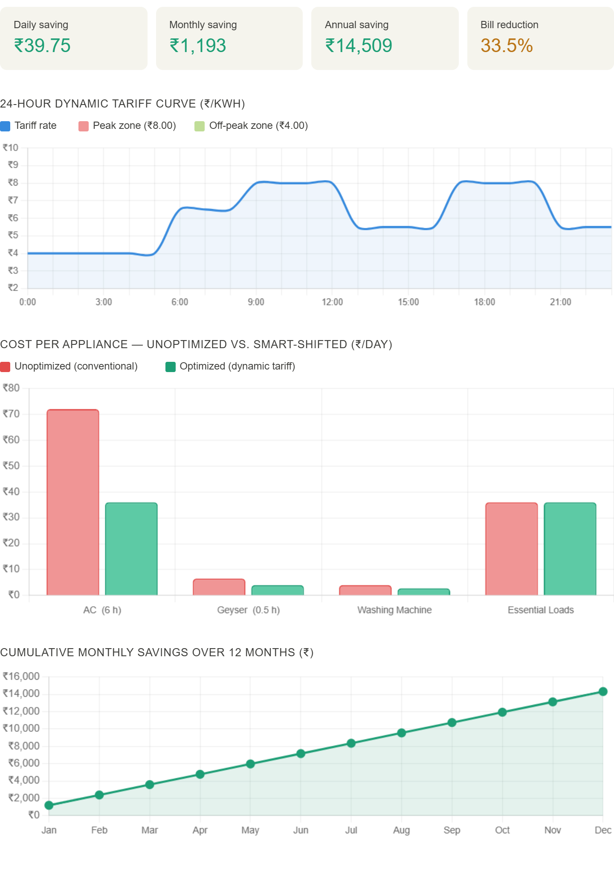

Figure 3.5 Energy Saving Graph
CHAPTER 5

END SECTION
REFERENCES / BIBLIOGRAPHY
The information and concepts used in this project were referred from various reliable online sources, technical platforms, datasheets, and academic publications. These references helped in understanding smart metering technology, IoT implementation, energy management algorithms, and real-world applications.

1. Arduino – Official Documentation and IDE
Programming and interfacing ESP32 using Arduino IDE, library documentation, serial monitor usage.
https://www.arduino.cc/
2. Espressif Systems – ESP32 Technical Reference Manual
ESP32 datasheet, GPIO specifications, UART configuration, Wi-Fi stack, ADC operation, and power management.
https://www.espressif.com/en/products/socs/esp32
3. Electronics Hub – Embedded System and IoT Circuits
Circuit design, relay interfacing, voltage divider networks, and sensor integration guides.
https://www.electronicshub.org/
4. Circuit Digest – Smart Meter and IoT Projects
PZEM-004T interfacing with ESP32, Modbus UART communication, energy meter firmware examples.
https://circuitdigest.com/
5. Random Nerd Tutorials – ESP32 and IoT Implementations
ESP32 WebServer, HTML/CSS dashboard hosting, HTTP API design, TFT_eSPI library usage.
https://randomnerdtutorials.com/
6. All About Circuits – Theoretical Component Analysis
Relay operation, current transformers, Hall-effect sensors, snubber circuits, AC switching theory.
https://www.allaboutcircuits.com/
7. Electrical4U – Basic Electrical Concepts and Theory
Energy metering fundamentals, power factor, kWh calculation, smart grid overview, prepaid metering.
https://www.electrical4u.com/
8. IEEE Xplore – Research Papers on Smart Metering
Technical standards for smart meters, AMI (Advanced Metering Infrastructure), dynamic pricing literature.
https://ieeexplore.ieee.org/
9. ResearchGate – Smart Meter Research and Studies
Academic papers on IoT-based energy meters, theft detection algorithms, and prepaid billing systems.
https://www.researchgate.net/
10. Instructables – Practical Project Implementations
Step-by-step project guides for ESP32-based energy meters, relay control, and IoT dashboards.
https://www.instructables.com/
11. PZEM-004T V3.0 Datasheet – Peacefair
Technical specifications for the PZEM-004T energy measurement module including Modbus RTU protocol.
Available from supplier documentation
12. ACS712 Datasheet – Allegro Microsystems
Hall-effect current sensor specifications, sensitivity values, and application circuit for ±5A variant.
https://www.allegromicro.com/
13. TFT_eSPI Library Documentation – Bodmer
SPI TFT display library for ESP32/Arduino with ILI9341 driver, font rendering, and color support.
https://github.com/Bodmer/TFT_eSPI
14. Energy Efficiency Services Limited (EESL), India
Smart meter deployment in India, national smart grid mission, AT&C loss reduction data.
https://www.eeslindia.org/
15. Bureau of Energy Efficiency (BEE), India
Electricity tariff structure in India, time-of-use pricing, energy conservation guidelines.
https://beeindia.gov.in/

